1. Successful installation of EMBOSS.


2. Using EMBOSS, find the complementary strand for the sequence:
5’ - CTCGGATTTGTAAAGATCATGATCTCATACATAGTACCTAGCCATTG - 3’
3’ - GAGCCTAAACATTTCTAGTACTAGAGTATGTATCATGGATCGGTAAC - 5’

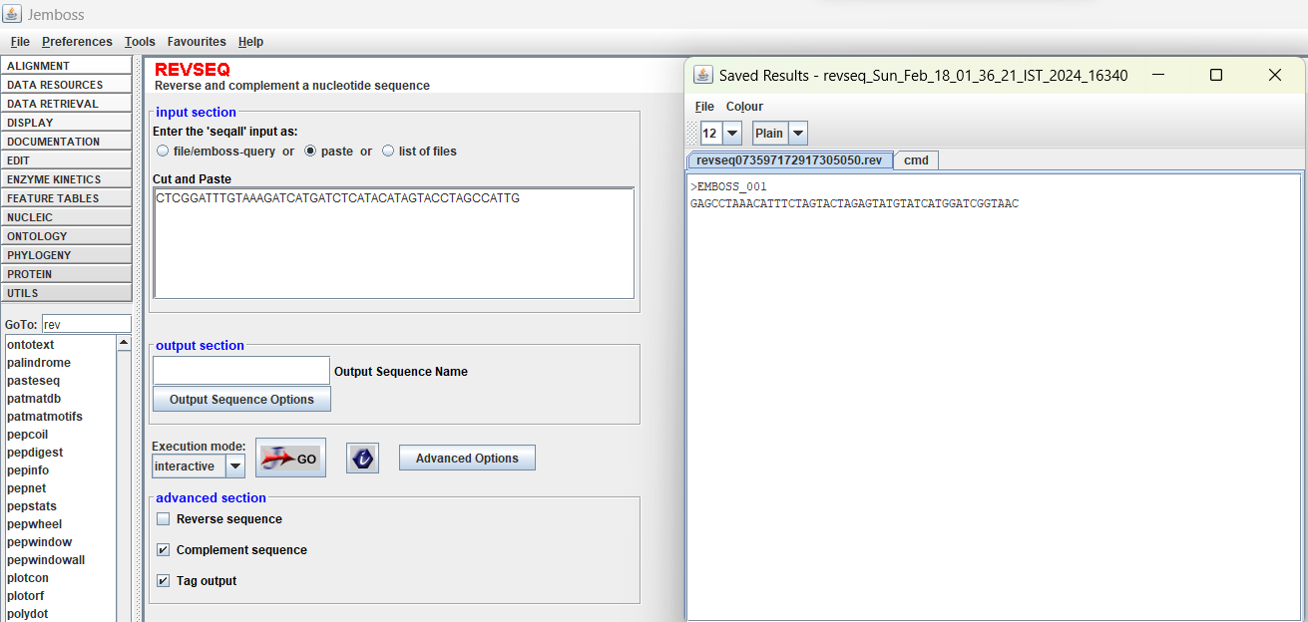

3. A C++ program for finding the complementary strand for the sequence given in Q2.
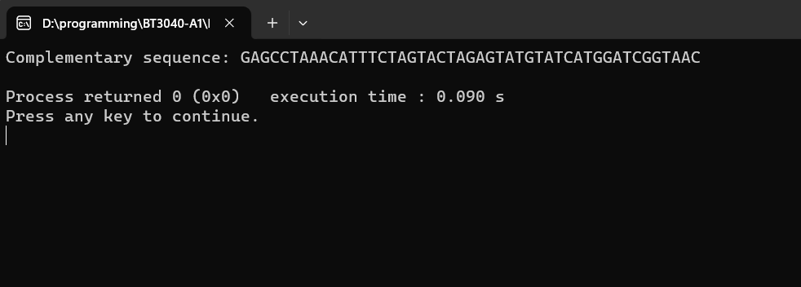

4.
i. The translated sequence using EMBOSS:
DIVNSKKVHAMRKEQKRKQGKQRSMGSPMDYSPLPIDKHEPEFGPCRRKLDG
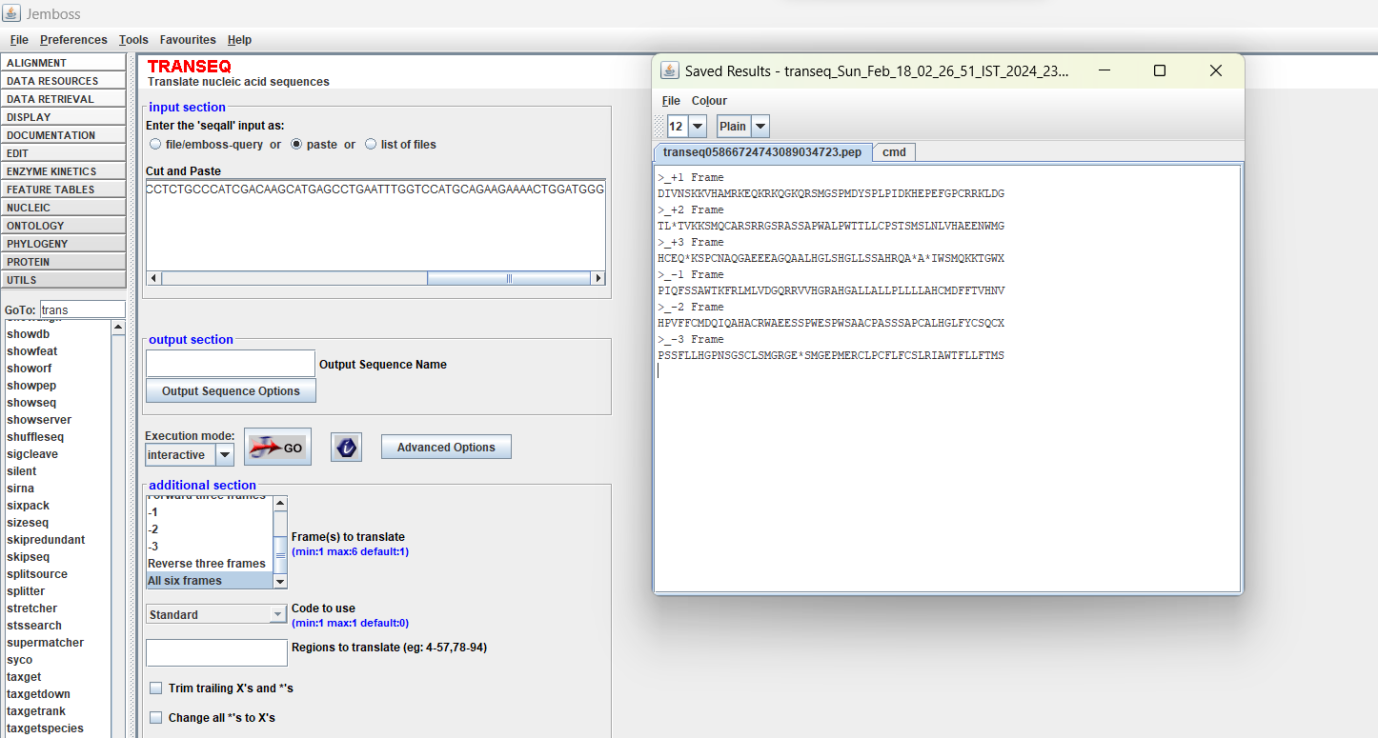

ii. The -1 reading frame matches with the given reading frame.
PIQFSSAWTKFRLMLVDGQRRVVHGRAHGALLALLPLLLLAHCMDFFTVHNV

5. A C++ program to translate the given DNA sequence (from Q4).
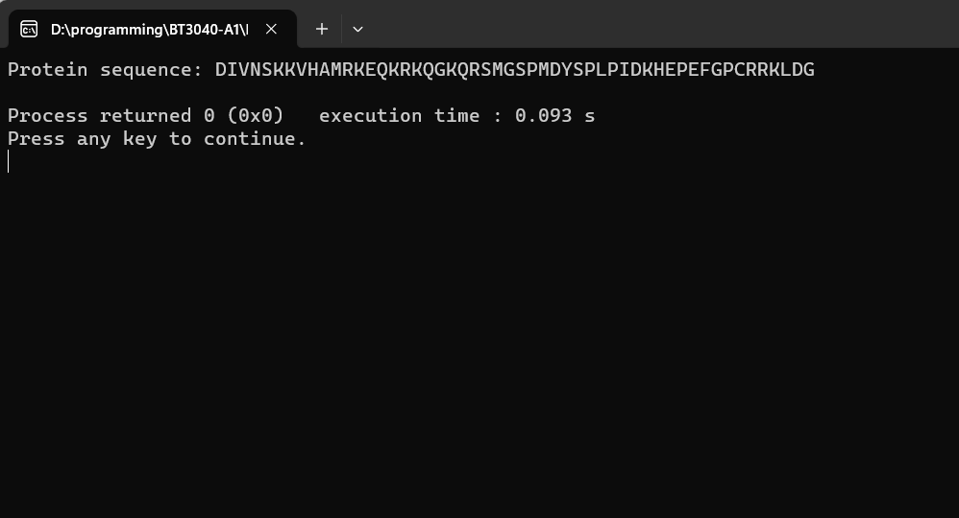

6. A C++ code that searches for the given query subsequences in the main sequence and lists down the total number of matches and the start position of the match.

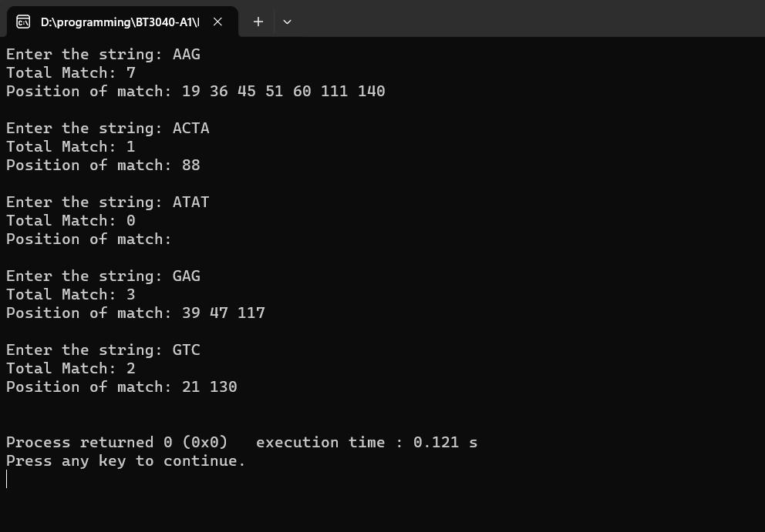
7. Familiarizing with other tools in EMBOSS.
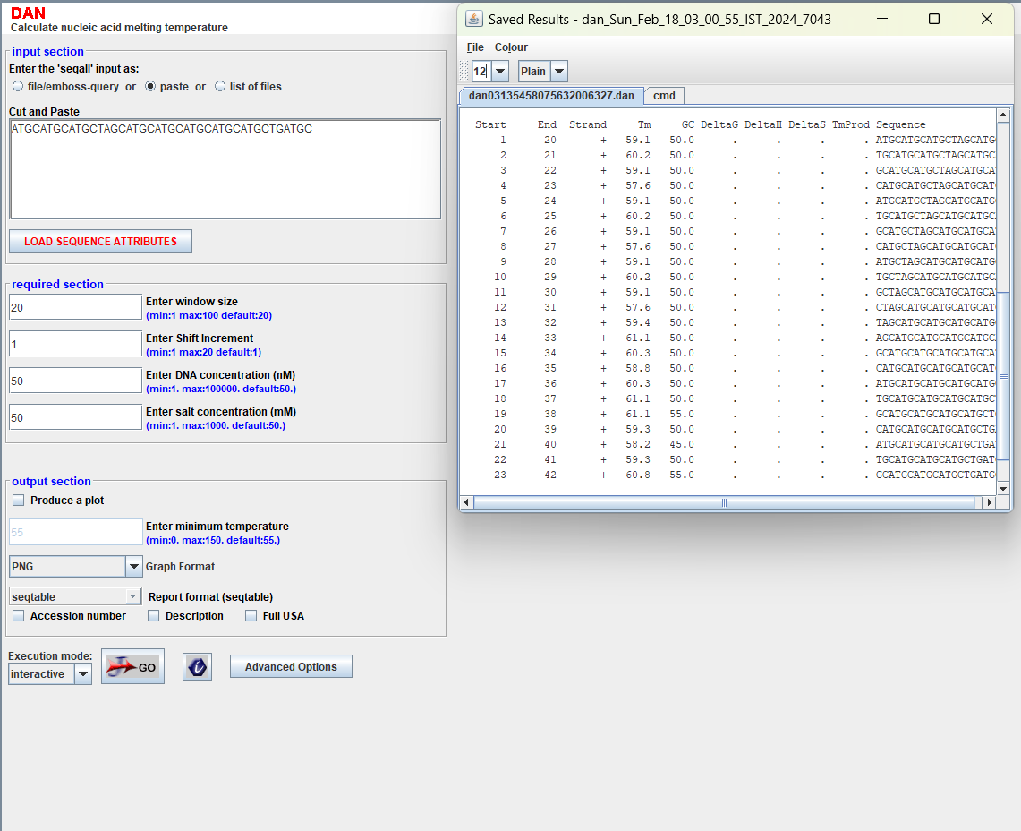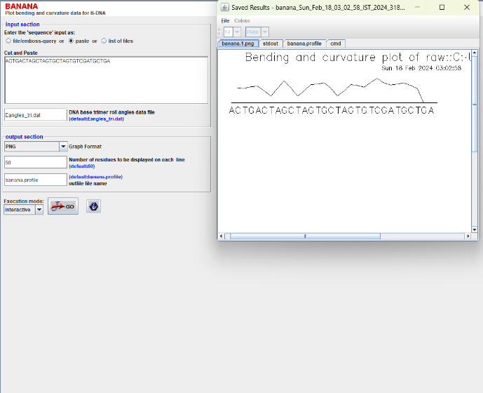

8. A C++ program to find the average stacking energy of the given sequence.
5’ - CTCGGATTTGTAAAGATCATGATCTCATACATAGTACCTAGCCATTG - 3’

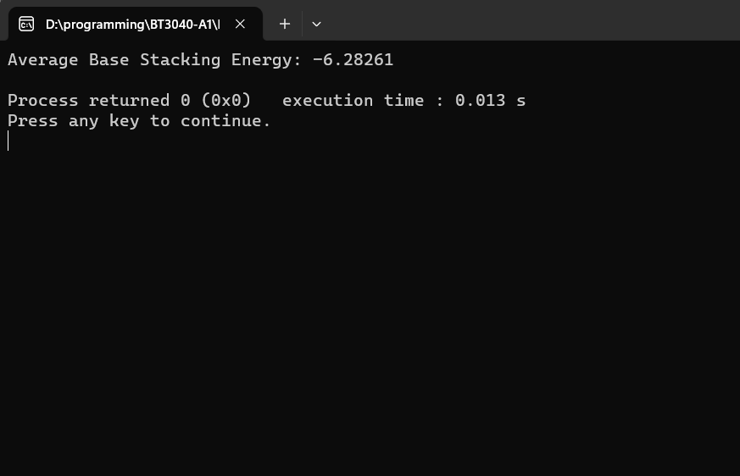

9. Computing the average melting temperature for the following sequences using Seq2Feature tool.
i. ATATATATAT
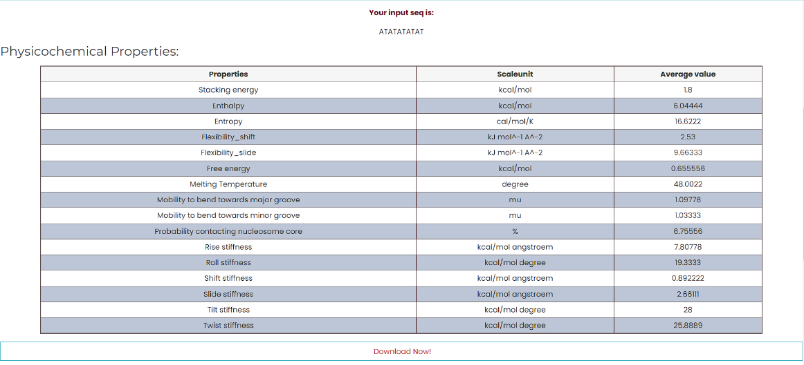

ii. GCGCGCGCGC
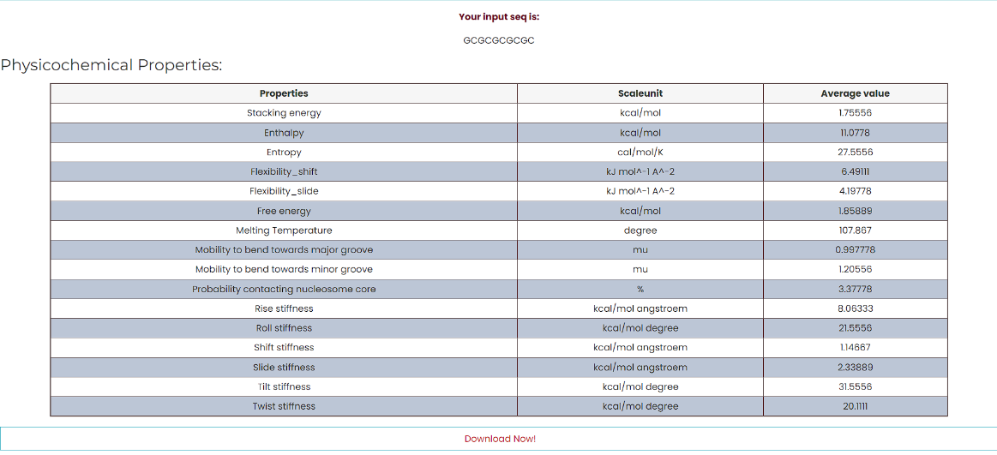

Melting temperature for sequence (i) is found out to be 48.0022º C, whereas the melting temperature for sequence (ii) is 107.867º C. This almost more than double of a difference in their melting temperatures indicates high bonding energy between G and C compared to A and T and we know this is true as there is a triple hydrogen bond between G and C and a double hydrogen bond between A and T. Therefore, this huge difference in melting temperature can be explained with the above reasoning.

10. Calculating the AT and GC content of the sequence AAATGGCCCTAA using Seq2Feature tool.
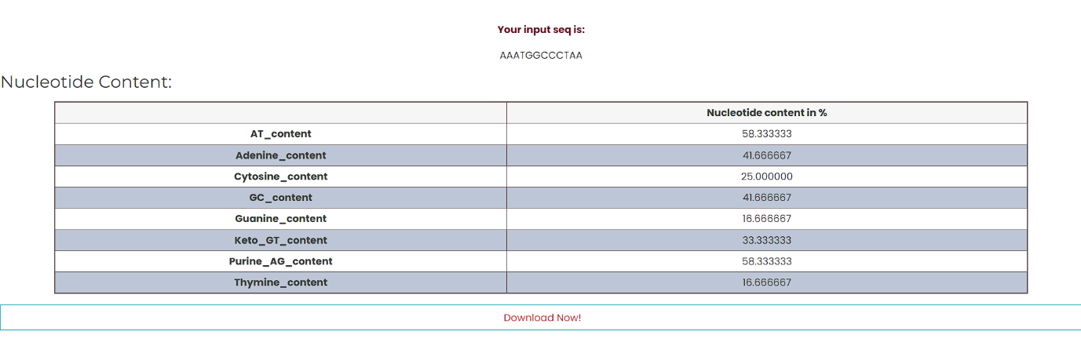
AT content: 58.33%
GC content: 41.67%
The End

